Software Lab: Infrastructure as Code using Terraform
Objective
The objective of this lab is to introduce yourself to Infrastructure as Code (IaC) using Terraform. You will learn how infrastructure can be created, modified, and managed using configuration files instead of manual setup.
By the end of this lab, you should be able to:
- Understand the Terraform workflow (init, plan, apply, destroy).
- Write Terraform configuration files.
- Use variables and outputs.
- Create reusable Terraform modules.
- Manage container infrastructure using Docker through Terraform.
- Perform basic infrastructure validation using CI workflows.
- Dynamically generate infrastructure resources using Terraform expressions.
The lab consists of multiple assignments that build progressively on one another.
You will use a free repository hosting platform for submission: GitHub.
Software Requirements:
You must install the following tools before starting the lab:
- Terraform CLI
- Docker (Docker Desktop or Docker Engine)
- Git
- A GitHub account for repository submission
No paid subscriptions or cloud services are required for this lab.
General Lab Structure
You must create a single repository containing folders for each assignment. Each assignment builds on the previous one and increases slightly in complexity.
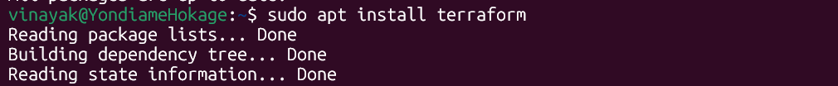
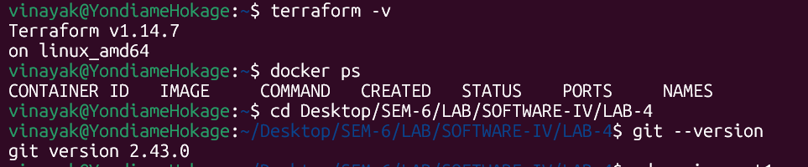
Assignment 1: Introduction to Terraform
Objective
Understand the Terraform workflow and create a simple infrastructure resource.

Tasks
- Install Terraform on your system.
- Create a directory named:
terraform-lab/day1
- Write a Terraform configuration file that:
  - Uses the local provider
  - Creates a file named hello.txt
  - Writes the message “Hello from Terraform” inside the file.
- Execute the following commands:
terraform init
terraform plan
terraform apply
- Verify that the file hello.txt has been created.
- Add a variable called message and modify the configuration to use the variable instead of hardcoding the text.
- Add an output variable to display the file path.
Expected Learning:
- Terraform initialization
- Execution planning
- Infrastructure application
- Basic configuration structure
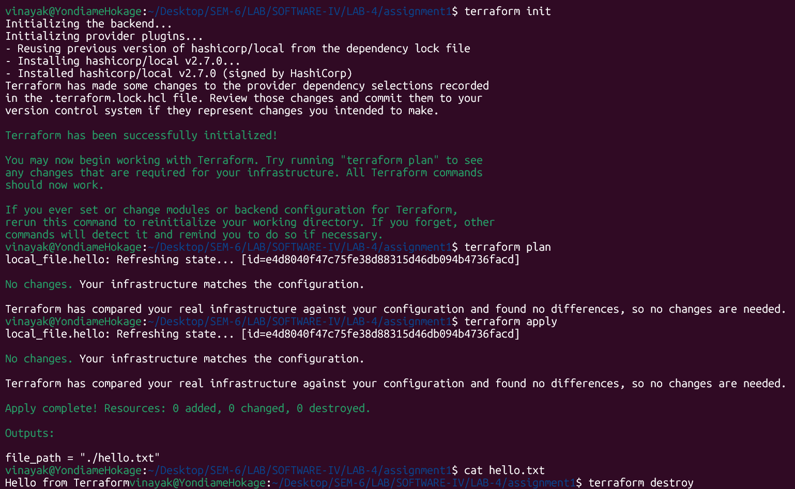
Destroy:
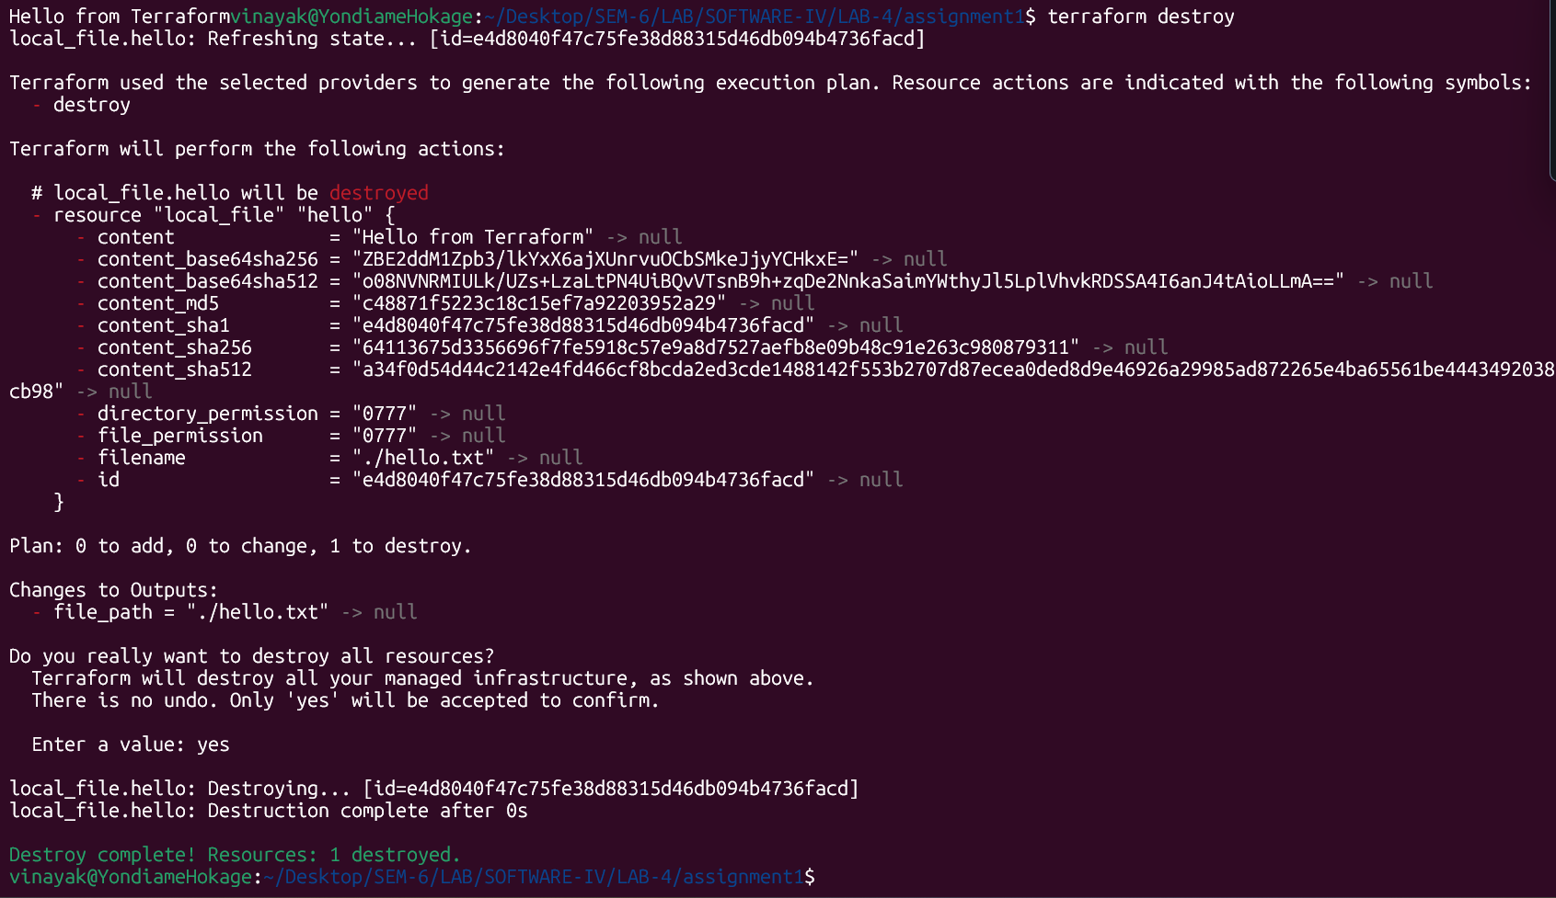

Assignment 2: Variables and Multiple Configurations
Objective
Understand how to parameterize Terraform configurations using variables and variable files.
Tasks
- Create a directory:
terraform-lab/day2
- Modify the configuration so that:
  - The filename is a variable
  - The message content is a variable
- Create two variable files:
dev.tfvars
Prod.tfvars
For example dev.tfvars
filename = "dev.txt"
message = "Development environment"
For example prod.tfvars
filename = "prod.txt"
message = "Production environment"
- Execute Terraform with different variable files.
Example commands:
terraform apply -var-file="dev.tfvars"
terraform apply -var-file="prod.tfvars"
Expected Learning:
- Input variables
- Variable files
- Environment-based configuration
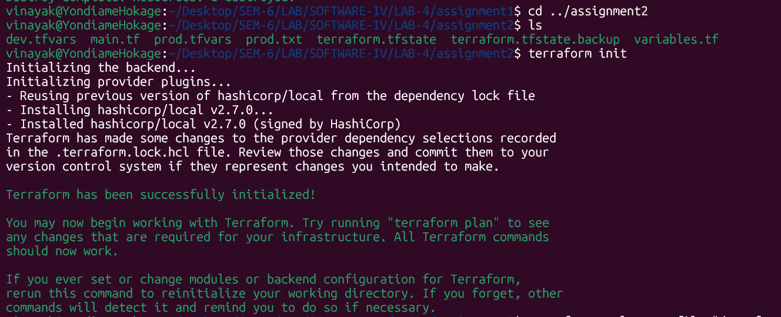
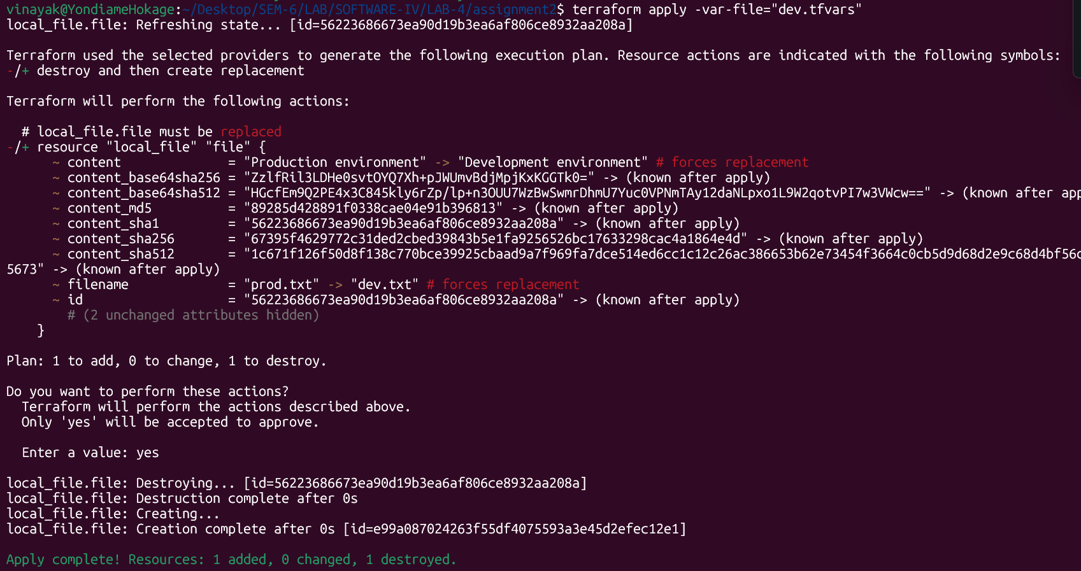
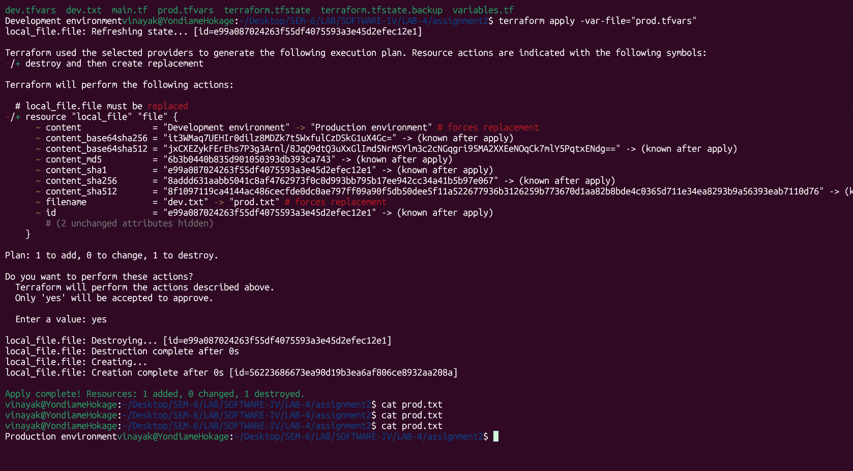

Assignment 3: Managing Containers with Terraform
Objective
Use Terraform to create and manage Docker containers locally.
Tasks
- Create a directory:
terraform-lab/day3
- Configure the Docker provider in Terraform.
- Write Terraform configuration that:
- Pulls the nginx image
- Creates a Docker container
- Maps container port 80 to host port 8080
- Run Terraform and verify the container is running.
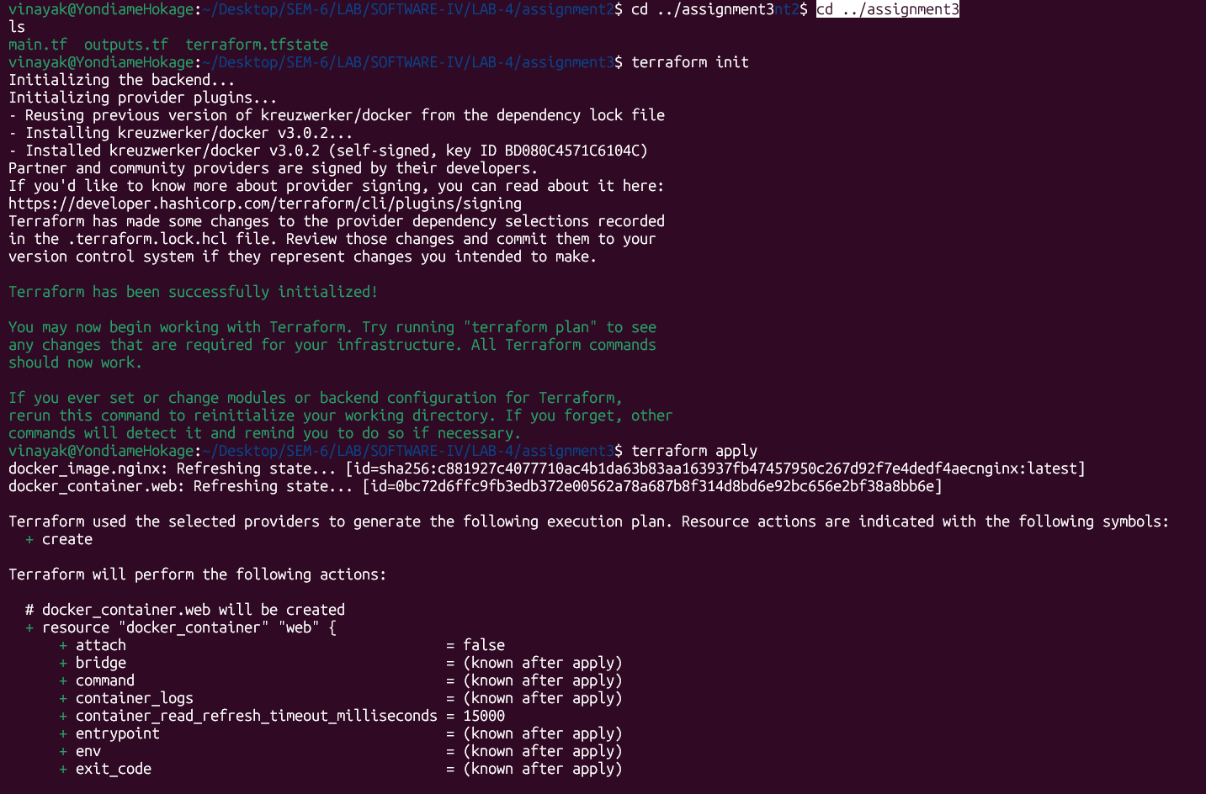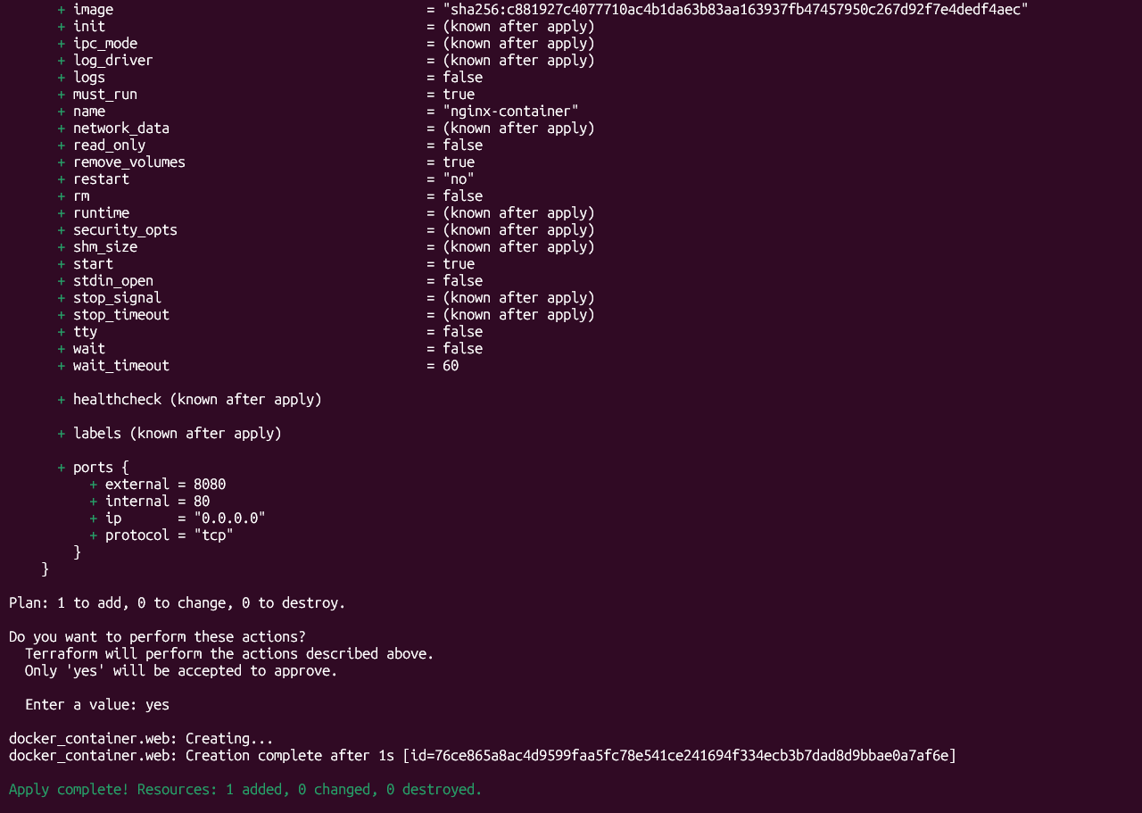

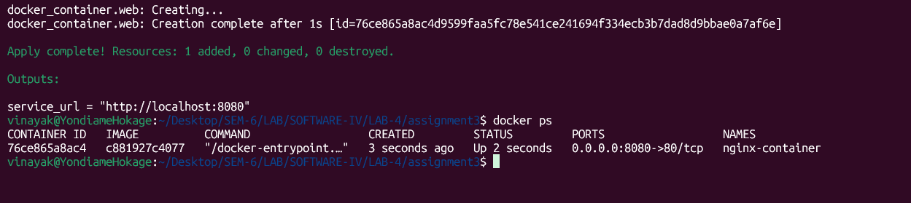
Open the following in a browser:
http://localhost:8080
- Add an output variable that prints the service URL.
Expected Learning:
- Terraform providers
- Container provisioning
- Managing services using infrastructure code
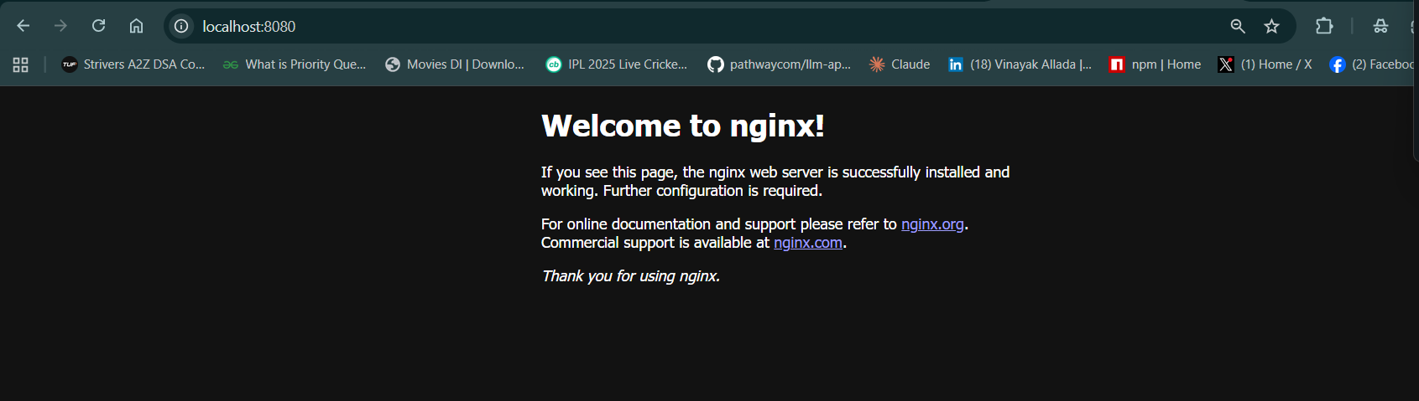

Assignment 4: Terraform Modules
Objective
Learn how to structure Terraform configurations using modules.
Tasks
- Create the following directory structure:
terraform-lab/day4
modules/nginx_container
- Move the container creation logic from Assignment 3 into the module.
- The module should accept the following variables:
container_name
container_port
Image_name
- The root configuration should call this module.
- Use the module to create two containers running on different ports:
8081
8082
Expected Learning:
- Terraform modules
- Reusable infrastructure components
- Modular infrastructure design
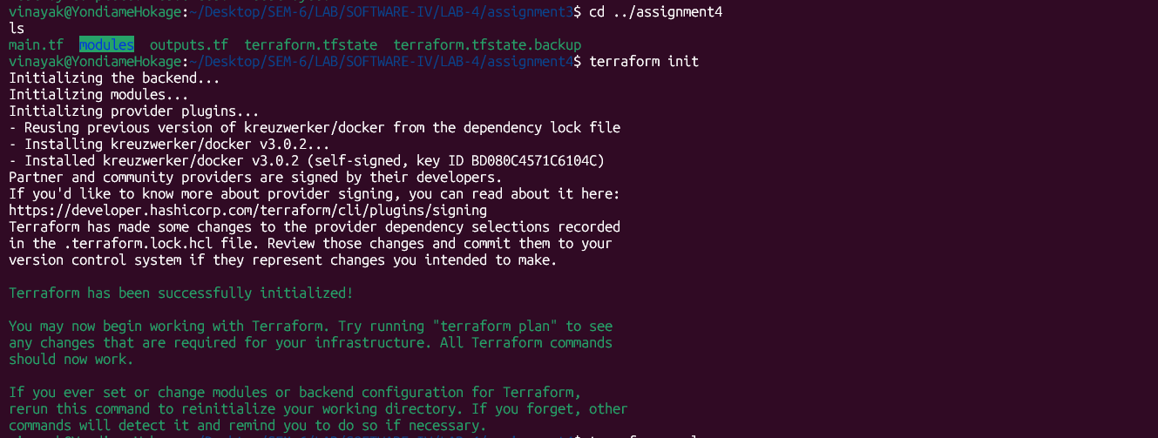
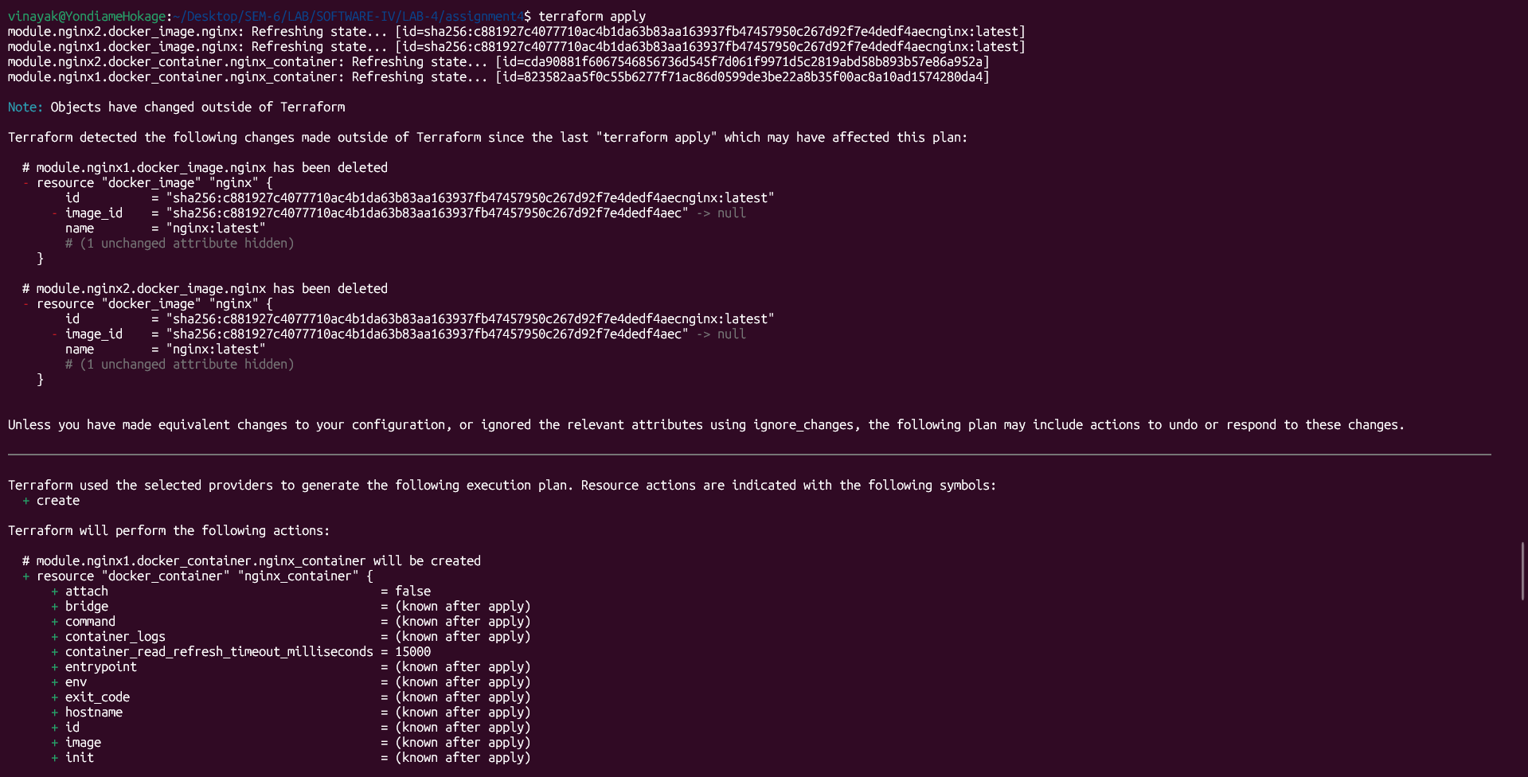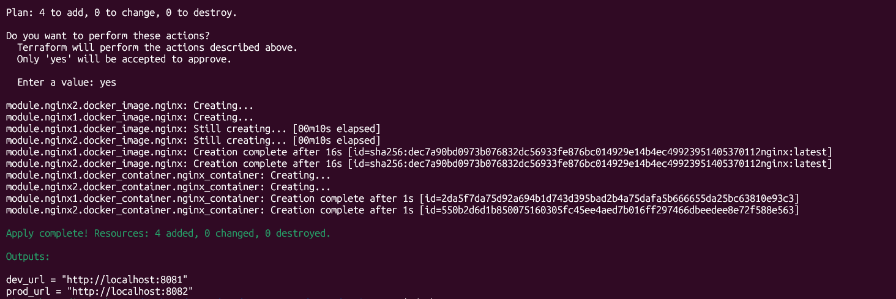

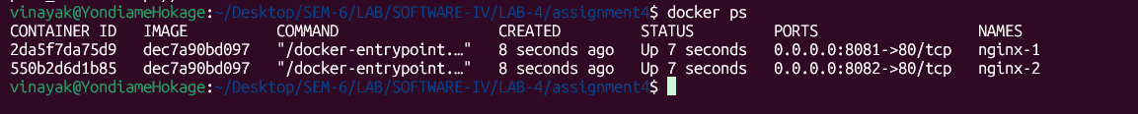
8081:
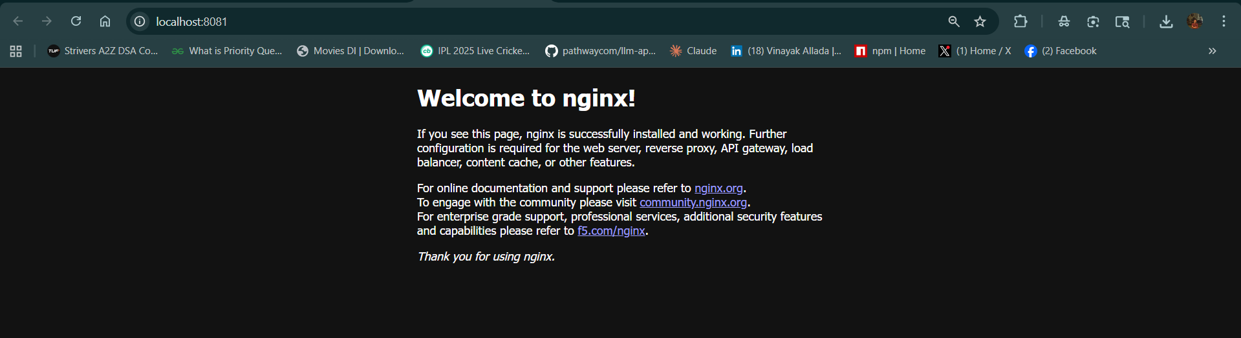
8082:
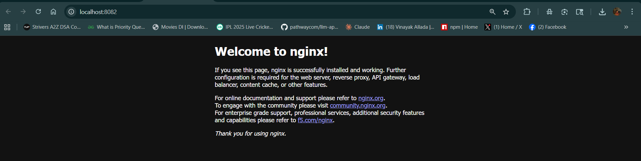

Assignment 5: Automation and Validation
Objective
Automate Terraform validation using a CI workflow.
Tasks
Create an automated workflow that runs whenever code is pushed to the repository.
The workflow must run the following commands:
terraform fmt
terraform validate
terraform plan
The workflow file should be placed inside:
.github/workflows/terraform-check.yml
Expected Learning:
- Infrastructure validation
- CI automation
- Code quality checks for Terraform configurations
- Link: link(repo link)
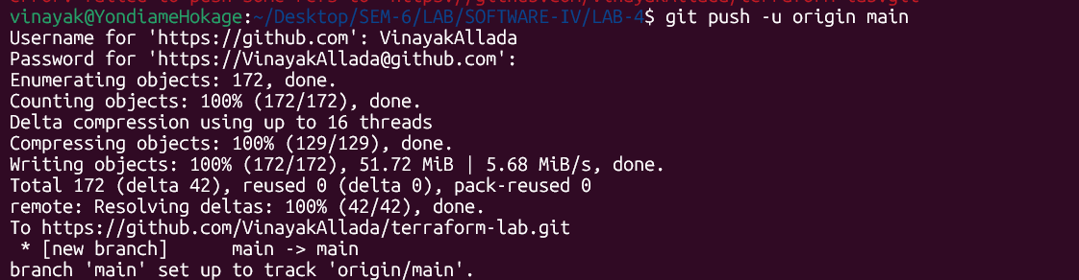

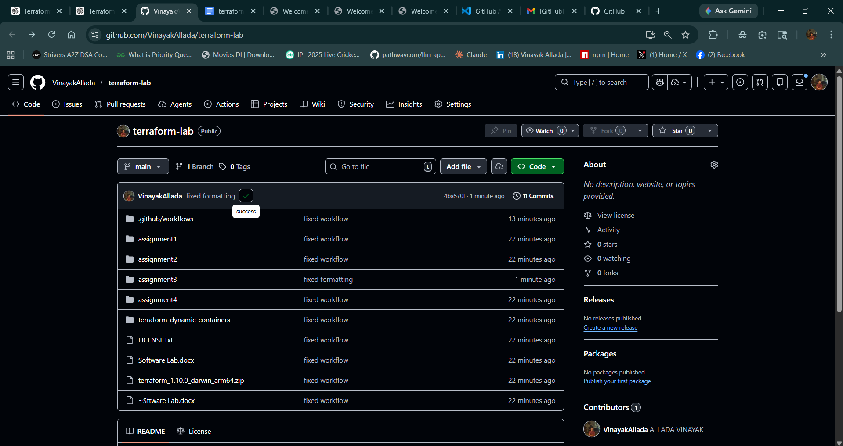

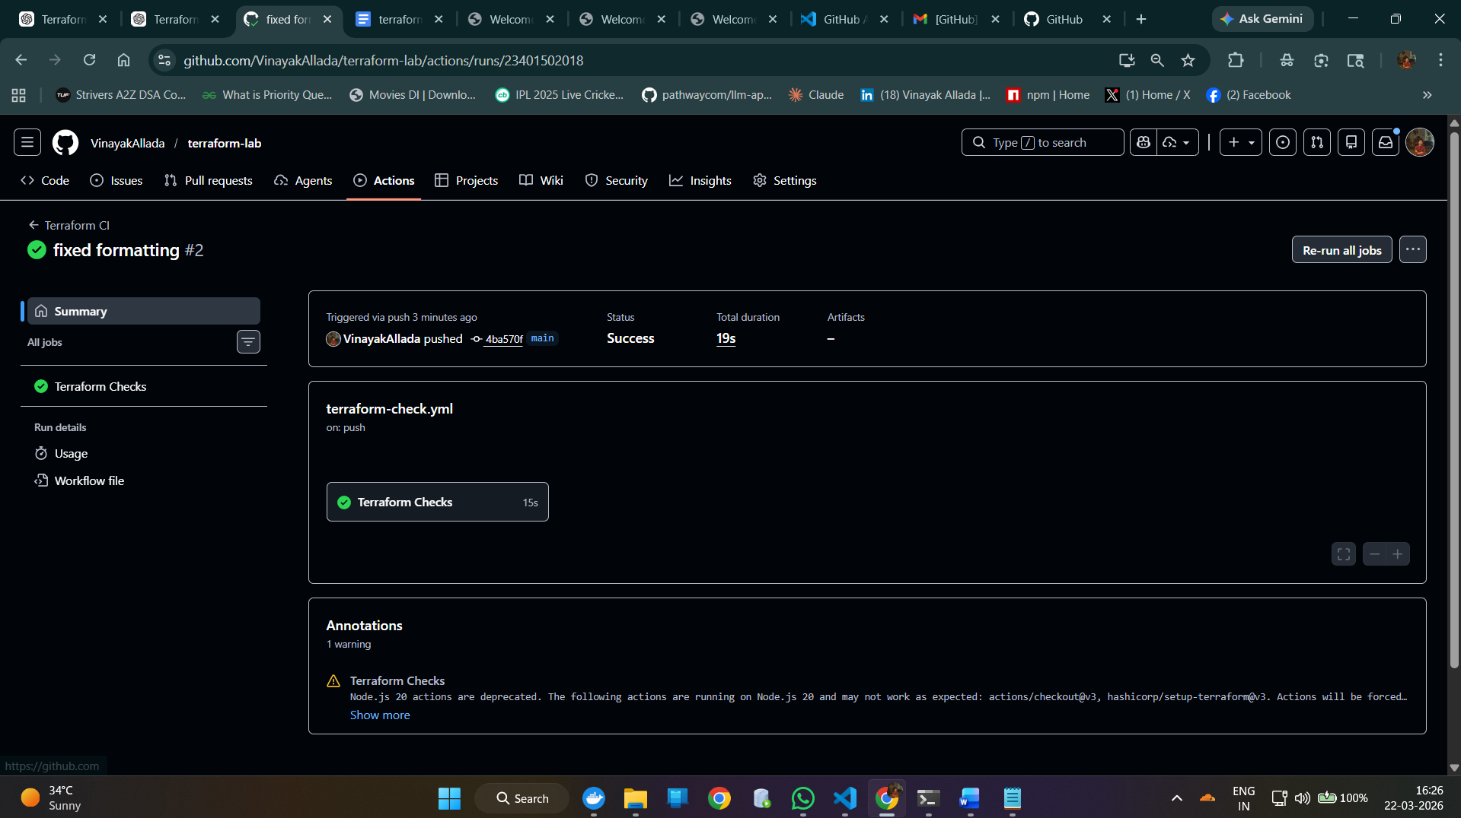

Added - # testing github actions and ran the code again.
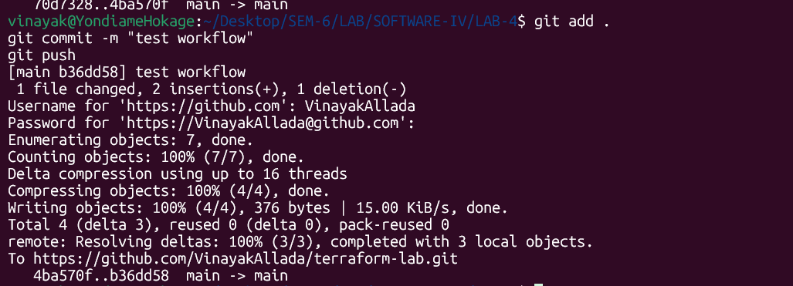
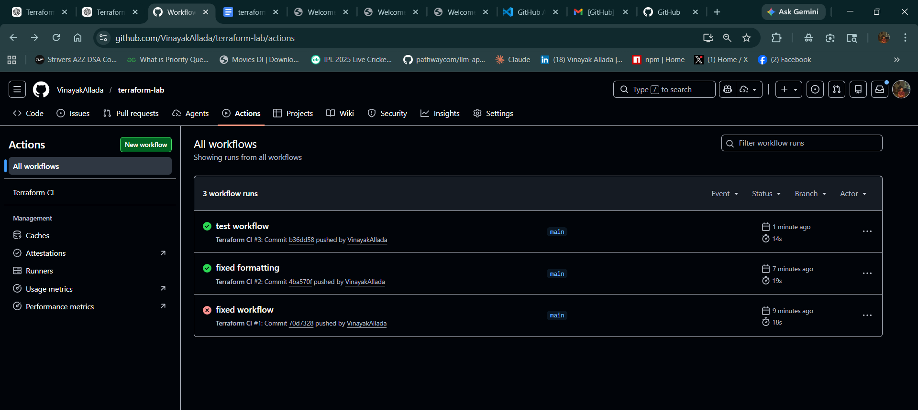

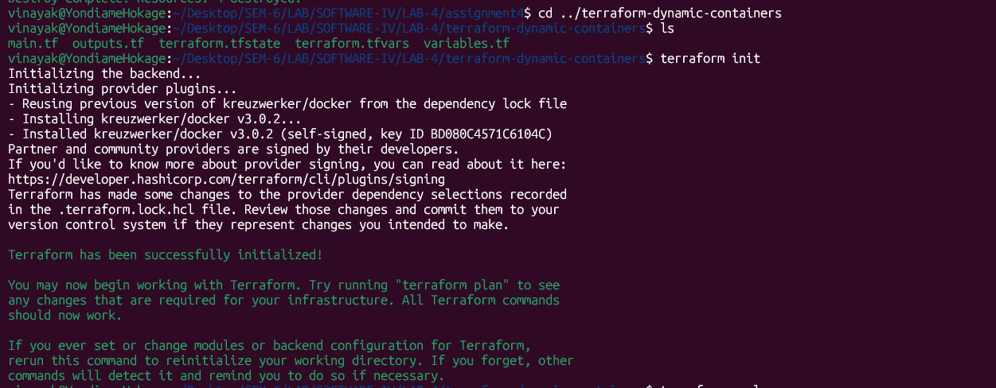

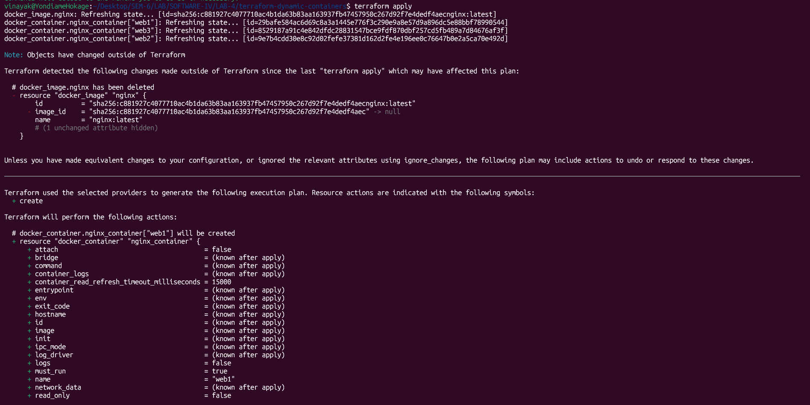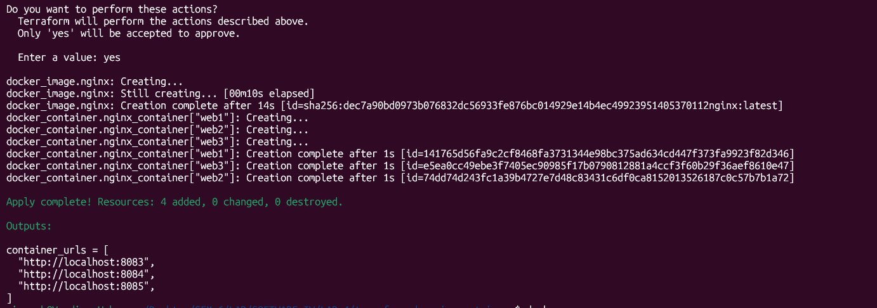

8083:
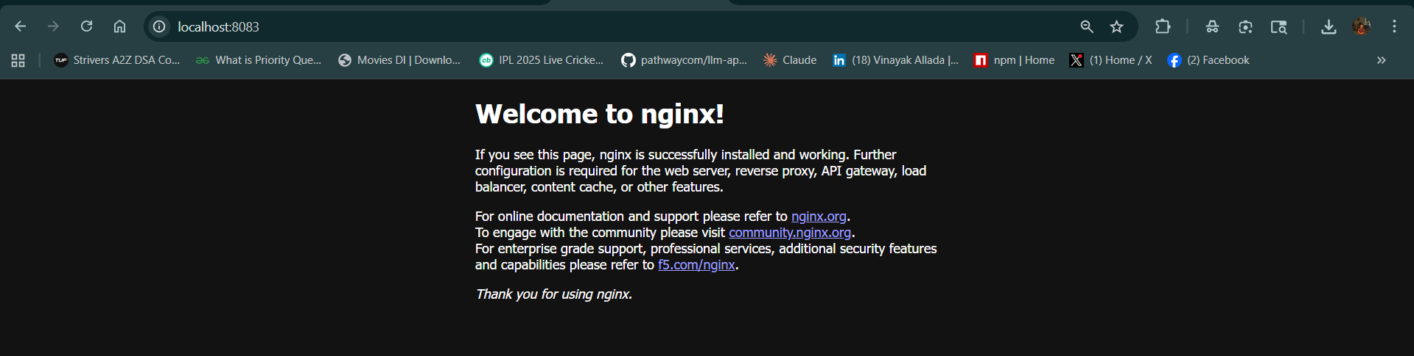
8084:
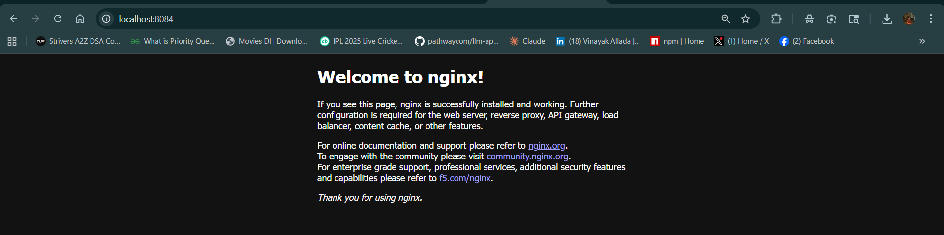
8085:
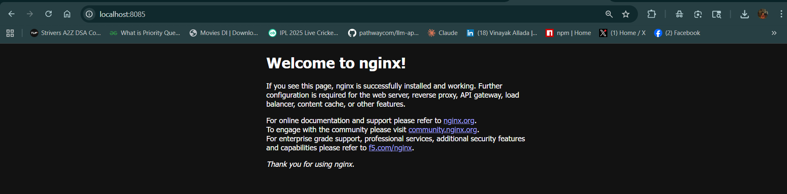

Advanced Bonus Challenge (for interested and ambitious students only): Dynamic Infrastructure Creation
Objective
Automatically generate multiple containers using Terraform expressions and loops instead of manually defining each resource.
Problem Statement
You must extend the module-based infrastructure from Assignment 4 to dynamically create multiple containers based on input configuration.
Requirements
- Define a variable named container_config that contains a list of container specifications.
Example configuration:
container_config = [
{
name = "web1"
port = 8081
},
{
name = "web2"
port = 8082
},
{
name = "web3"
port = 8083
}
]
- Terraform must dynamically create one container for each configuration entry.
- Each container must:
- Use the nginx image
- Have a unique name
- Run on the specified port
- When new containers are added to the list, Terraform should automatically create them.
Expected Terraform Concepts
you should use one of the following:
for_each
or
Count
Expected Behavior
After deployment, the following URLs should work:
http://localhost:8081
http://localhost:8082
http://localhost:8083
Additional Requirement:
you must create an output variable that prints all container URLs.
Example output:
container_urls = [
"http://localhost:8081",
"http://localhost:8082",
"http://localhost:8083"
]
Deliverables
you must submit:
- Updated Terraform configuration
- Variable definition files
- Screenshot showing multiple running containers
- Output of terraform plan demonstrating dynamic resource creation

